

**YEAR 12 UNIT 4 HUMAN BIOLOGY**

**TEST 3 MUTATIONS & GENE POOLS**

|  |  |  |  |
| --- | --- | --- | --- |
| **Name:** | **Teacher:** | **Date:** | **Mark:** |

**Assessment Type:** Test

**Conditions:**

Time for the task: 55 minutes

**Task Weighting: 5%**

|  |  |  |
| --- | --- | --- |
| **Sections** | **Marks Allocation** | **Your Total** |
| **1 - Multiple Choice** | 10 |  |
| **2 – Short Answer** | 30 |  |
| **3 – Extended Answer** | 20 |  |
| **TOTAL** | 60 |  |

**Section One: Multiple-choice (10 marks)**

Suggested working time: 10 minutes

1. Mutations that occur in body cells are called:
2. germline.
3. somatic.
4. gene.
5. autosomal.
6. Genetic traits that are determined by two or more pairs of genes are:
7. multi-allelic.
8. co-dominance.
9. polygenic.
10. incomplete dominance.
11. Australian aboriginal people are adapted to living in the desert regions of Australia because:
12. they have a SA/V ratio of 1.2
13. they have a SA/V ratio of 0.9
14. they are endomorphic helps them to release heat more effectively
15. they have long trunks and short arms and legs
16. Thalassemia results in:
17. having anaemia with high iron levels
18. having anaemia with low iron levels
19. the need for iron tablets to supplement iron reserves
20. a dominant disease resulting in defects in haemoglobin formation
21. Populations that have become genetically isolated from one another:

1. usually have the same gene frequencies for physical characteristics
2. are not subject to random genetic drift
3. are subject to similar environmental selection pressures
4. may develop into different subspecies that are unable to interbreed
5. A mutation is a sudden change in the structure of a gene. Scientists link mutations to the process of natural selection very closely. Mutations:
6. always produce beneficial variations upon which natural selection can act
7. are of importance to natural selection only if they can pass from generation to generation
8. will improve the survival chances of an individual
9. result in random genetic drift
10. Tay-Sachs Disease is a hereditary disorder of:
11. lipid metabolism
12. protein metabolism
13. carbohydrate metabolism
14. vitamin D synthesis
15. Humans throughout the world are considered by scientists to belong to a single species because they all:
16. make use of manufactured tools
17. can interbreed to produce offspring
18. have binocular colour vision
19. use language and symbols as a means of cultural transmission

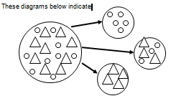

1. These diagrams indicate:
2. migration
3. founder effect
4. genetic drift
5. geographical barrier
6. Which best describes the genotype for sickle cell anaemia?
7. HAHS
8. hh
9. HSHS
10. Hh

**Section Two: Short answer (30 Marks)**

**Question 1**

1. Explain how the Bottleneck effect caused a large number of colour blind individuals in Pingelap during the 1800’s and 1900’s after a typhoon wiped out all but 20 inhabitants?

____________________________________________________________________________

____________________________________________________________________________

____________________________________________________________________________

____________________________________________________________________________

____________________________________________________________________________

____________________________________________________________________________

____________________________________________________________________________

(4 marks)

1. Suggest a factor that could have changed in the 1900’s to result in the reduced incidence

of genetically-inherited colour blindness in the Pingelap population.

____________________________________________________________________________

____________________________________________________________________________

(1 mark)

Dr Bruce’s misplaced slides

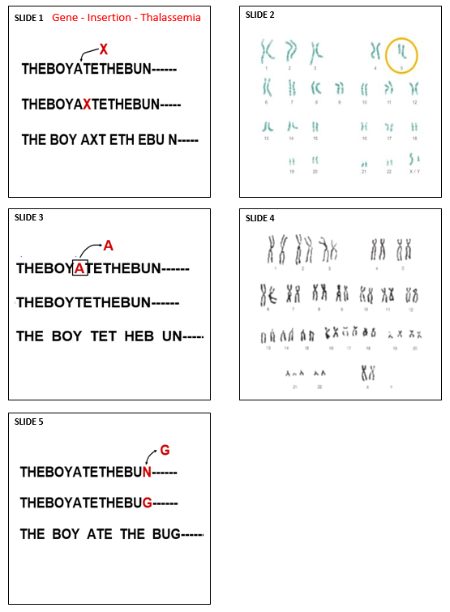

**Question 2**

Dr Bruce was preparing a series of medical lectures on mutations, but he accidentally left a draft copy of some of his unfinished numbered power point slides lying around [see attachment].

Can you add the extra information he is missing using the table below to help him out?

Slide 1 has been completed as an example for you to follow.

|  |  |  |  |  |
| --- | --- | --- | --- | --- |
| Slide Number | Mutation | Mutation type | Mutation description | Disease |
| 1 | Gene | Insertion | a nucleotide has been inserted into the DNA | Thalassemia |
| 2 |  |  |  |  |
| 3 |  |  |  |  |
| 4 |  |  |  |  |
| 5 |  |  |  |  |

(8 marks)

**Question 3**

The incidence of genetic diseases in certain populations illustrates the effects of different factors on the dynamics of gene pools.

1. Outline 2 conditions that are required to lead to an increased incidence of a particular genetic disease within a population.

____________________________________________________________________________

____________________________________________________________________________

____________________________________________________________________________

(2 marks)

1. A mutation is another type of evolutionary mechanism that can affect frequencies of alleles in populations. Explain the difference in consequences between a mutation occurring in a somatic cell and one occurring in a germ cell

____________________________________________________________________________

____________________________________________________________________________

____________________________________________________________________________

(2 marks)

**Question 4**

1. Name the disease that causes irregularly shaped red blood cells, pain and fatigue.

_______________________________________________________________________

(1 mark)

1. What population is it most common in?

(1 mark)

1. What other disease does this disease help protect against?

_______________________________________________________________________

(1 mark)

1. Explain why this disease is not prevalent in Australia

____________________________________________________________________________

____________________________________________________________________________

____________________________________________________________________________

(2 marks)

**Question 5**

Tay-Sachs disease is a disorder of lipid metabolism which occurs as a result of a gene mutation. The recessive allele prevents the gene from producing a protein that will be able to function in the body. These recessive mutations are considered `lethal recessives’, and in the case of the Tay-Sachs disease, this leads to the death of the embryo or foetus, or the early death of a child.

Using examples, explain how a lethal recessive mutation such as the Tay-Sachs disease brought about changes in the gene pool through the following two evolutionary mechanisms:

1. genetic drift

_________________________________________________________________________________________________________________________________________________________________________________________________________________________________________________________________________________________________________________________________________________________________________________________________________________________________________

_____________________________________________________________________________________

(4 marks)

1. natural selection

_________________________________________________________________________________________________________________________________________________________________________________________________________________________________________________________________________________________________________________________________________________________________________________________________________________________________________

_____________________________________________________________________________________

(4 marks)

**Section Three: Extended Answer (20 Marks)**

**Question 1 (10 marks)**

One physical variation found in human populations is skin colour. Skin colour changes gradually with distance from the equator. Describe this variation in skin colour and discuss the process by which natural selection has established this gradual change.

___________________________________________________________________________________

____________________________________________________________________________

____________________________________________________________________________

____________________________________________________________________________

____________________________________________________________________________

____________________________________________________________________________

____________________________________________________________________________

____________________________________________________________________________

____________________________________________________________________________

____________________________________________________________________________

____________________________________________________________________________

____________________________________________________________________________

____________________________________________________________________________

____________________________________________________________________________

____________________________________________________________________________

____________________________________________________________________________

____________________________________________________________________________

____________________________________________________________________________

____________________________________________________________________________

____________________________________________________________________________

____________________________________________________________________________

____________________________________________________________________________

____________________________________________________________________________

____________________________________________________________________________

____________________________________________________________________________

____________________________________________________________________________

____________________________________________________________________________

____________________________________________________________________________

____________________________________________________________________________

____________________________________________________________________________

____________________________________________________________________________

**Question 2 (10 marks)**

Some scientists believe that Homo antecessor may be the common ancestor of Homo sapiens [modern man] and Homo neanderthalensis. Describe the processes through which speciation may have occurred in producing two species.

___________________________________________________________________________________

____________________________________________________________________________

____________________________________________________________________________

____________________________________________________________________________

____________________________________________________________________________

____________________________________________________________________________

____________________________________________________________________________

____________________________________________________________________________

____________________________________________________________________________

____________________________________________________________________________

____________________________________________________________________________

____________________________________________________________________________

____________________________________________________________________________

____________________________________________________________________________

____________________________________________________________________________

____________________________________________________________________________

____________________________________________________________________________

____________________________________________________________________________

____________________________________________________________________________

________________________________________________________________________________________________________________________________________________________

____________________________________________________________________________

____________________________________________________________________________

____________________________________________________________________________

____________________________________________________________________________

____________________________________________________________________________

____________________________________________________________________________

____________________________________________________________________________

____________________________________________________________________________

____________________________________________________________________________

____________________________________________________________________________